Do the following & attach the screenshot of the same
1. Change the Firewall Name, time
Ans:
Go to “Device” in the functional tab and select “Setup” in the left column, under “Management” in “General Settings” you can change the Firewall Name and Time.
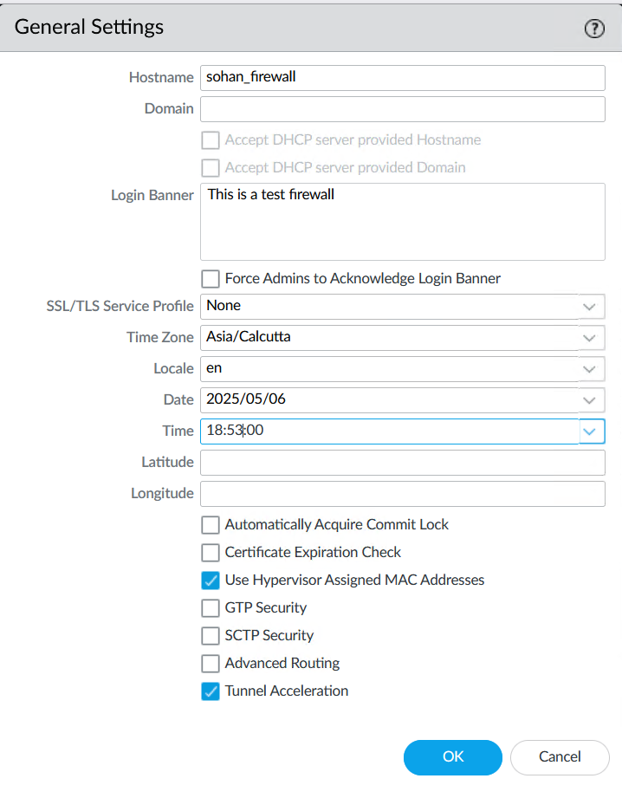
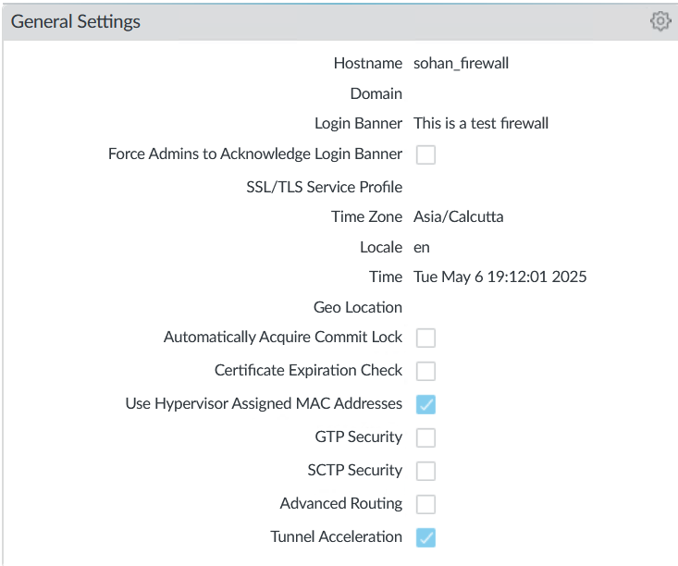
2. Write a banner and check if it is applicable.
Ans:
After going to the “Device” functional tab click on “Setup” in left column, under “Management” we can see “Banners and Messages” section
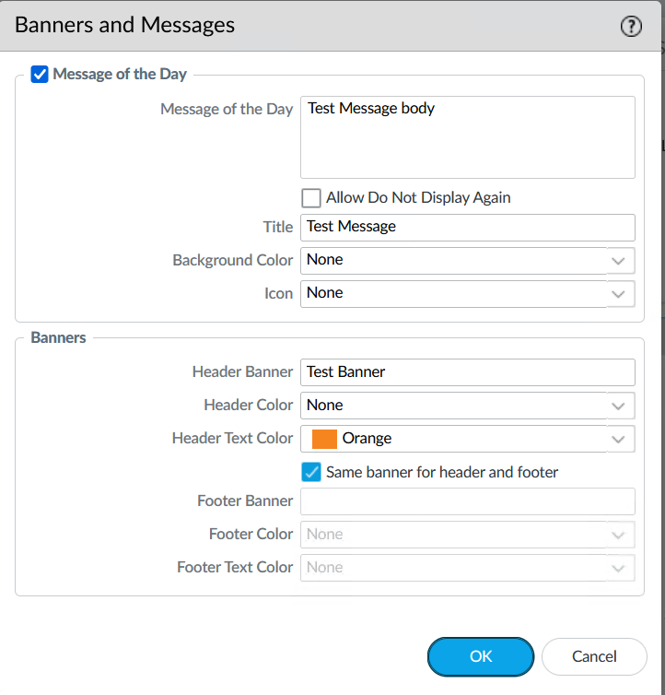
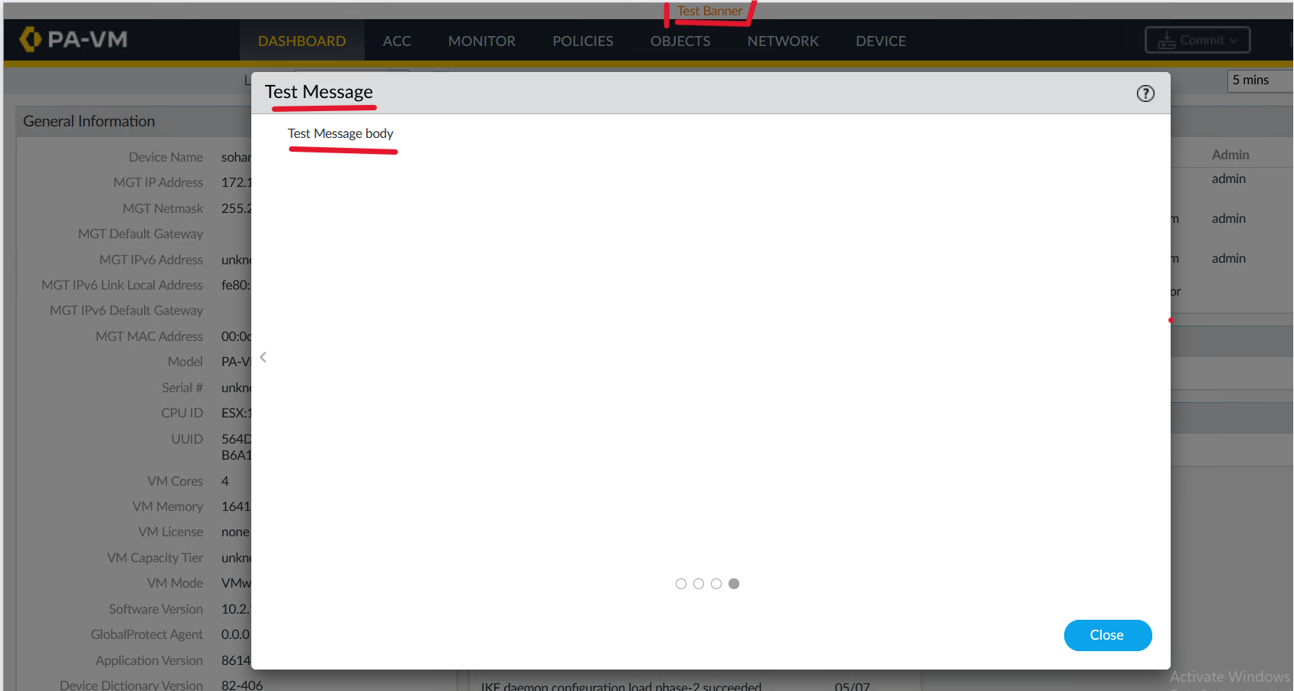
Here i have highlighted the “Banner Header” that is “Test Banner” and “Message of the Day” “Test Message body” and “Title” “Test Message”
3. Configure a complex password policy and check its validity.
Ans:
While still being under “Management” tab go to “Minimum Password Policy” and configure as per your requirement
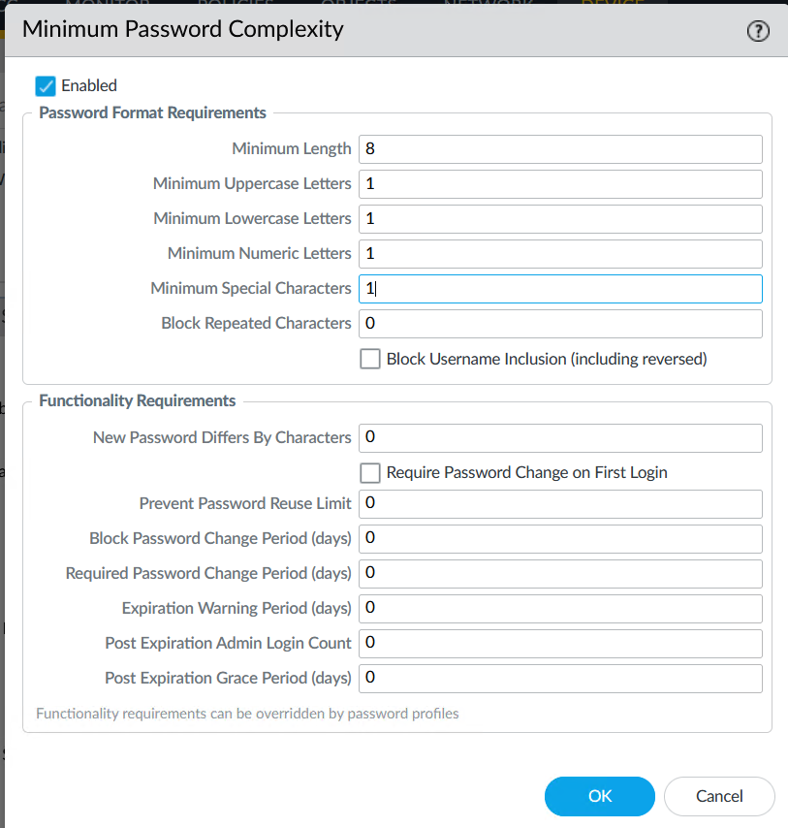
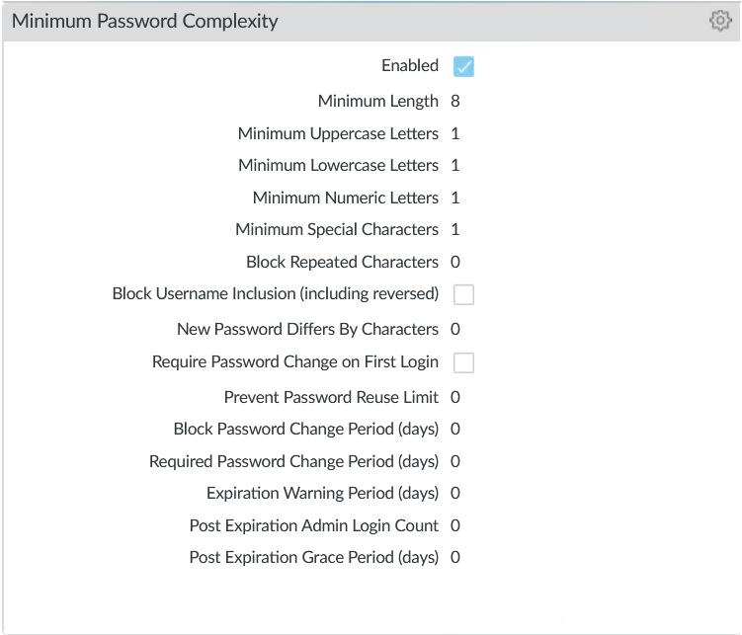
We can check it’s validity while creating the user test in question number 5
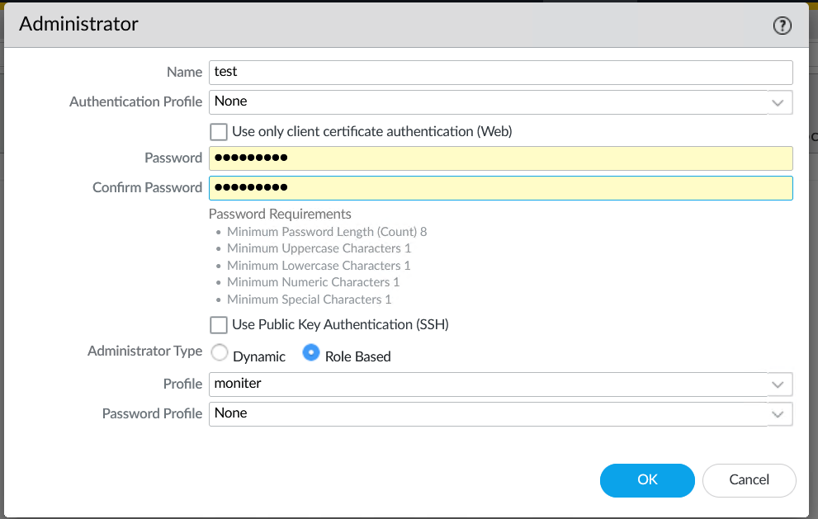
4. Create a role based profile.
While still being in “Device” functional tab go to the “Admin Roles” in the left column and click ‘add’ to add a role change relevant permissions like “enable”, “read only” and “disable” for various functionalities.
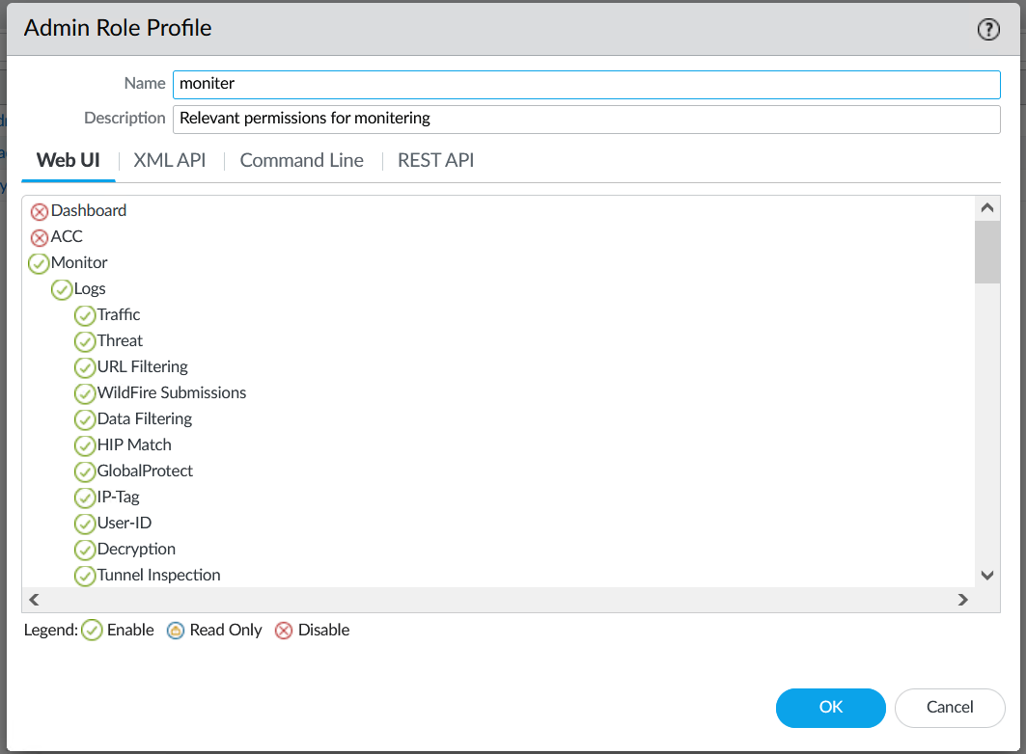
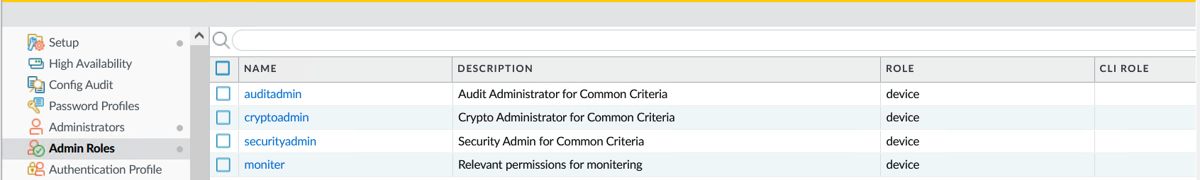
After clicking ok here we can see the role is successfully added.
5. Create a user and assign the profile created above and login using the user credentials.
We can create a user and assign the profile created above by going to “Administrators” section and clicking on ‘add’ button

We can see that the password policy we set before is working
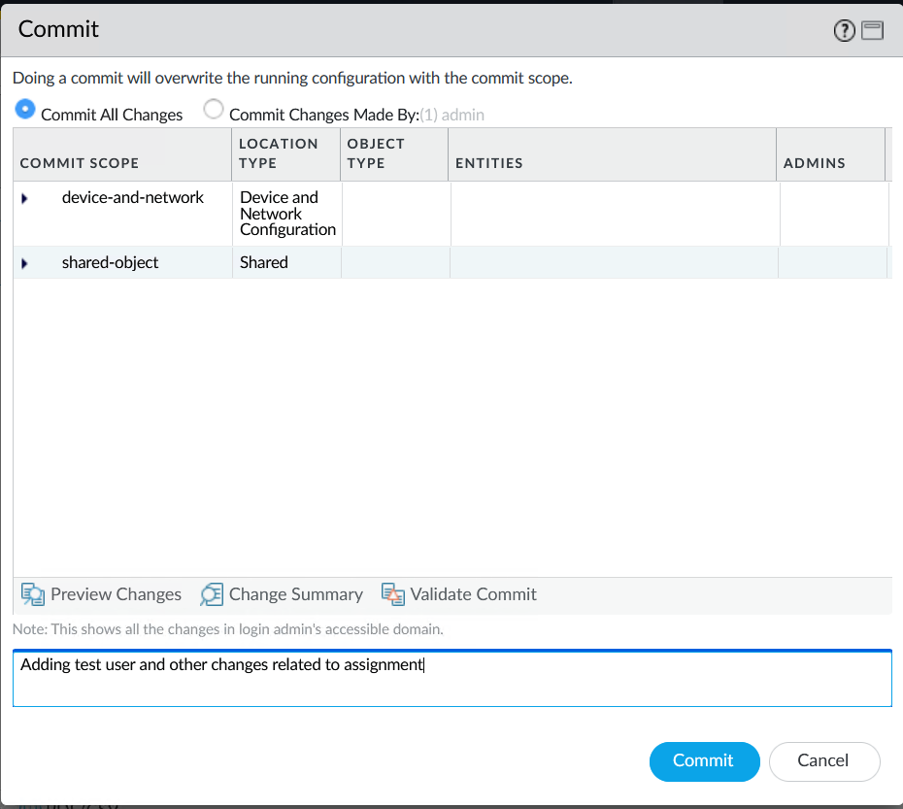
We should commit first so the user is created
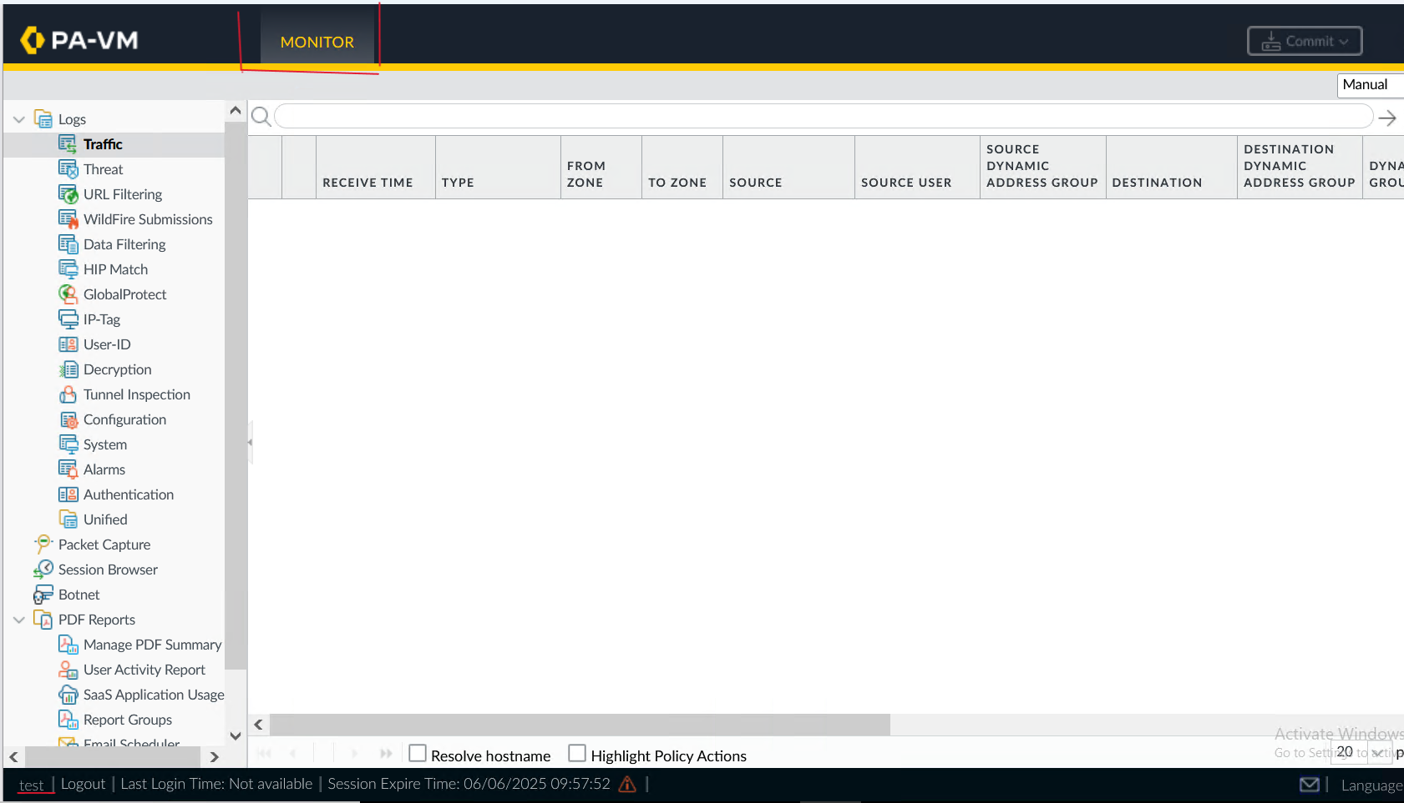
6. Commit the changes.
